**ABSTRACT**

Search engine optimization (SEO) is the practice of getting targeted traffic to a website from a search engine’s organic rankings. Since organic search is one of the ways through which people discover content online, higher rankings can translate to higher organic traffic to a website.Search Engine Optimization (SEO) is pivotal in enhancing online visibility and engagement. 'The Groco' represents a meticulously crafted online grocery platform developed by a team of enthusiastic front-end engineering students for their coursework. This project aimed to create a user-centric, intuitive, and SEO-optimized website, prioritizing visibility and accessibility in the digital retail landscape

SEO is often about making small modifications to parts of your website. When viewed individually, these changes might seem like incremental improvements, but when combined with other optimizations, they could have a noticeable impact on your site's user experience and performance in organic search results.

SEO includes both technical and content practices aimed to align with the best search engine algorithm needs. Common tasks associated with SEO include creating high-quality content, optimizing content around specific keywords, and building backlinks.

In other words:

“SEO is all about improving a site’s rankings in the organic (non-paid) section of the search results”

The project titled SEO friendly website aims at bringing these changes to an e-commerce website, With the intention to make the website more SEO friendly and thus rank higher in SERPs.

###### TABLE OF CONTENTS

|  |  |  |
| --- | --- | --- |
| Sr.no. | Section | Page no |
| 1. | Introduction | 1 |
| 2. | Problem Statement | 2 |
| 3. | Technical Details | 3 |
| 4. | Key Features | 4 |
| 5. | Project Advantages | 5 |
| 6. | Bonus Feature | 6 |
| 7. | Result | 7-8 |
| 8. | Conclusion | 9 |

1. **Introduction**
   1. **SEO friendly website**
      1. **Definition**

A SEO friendly website is an ordinary website (mostly E- commerce) but with highly optimized code such that it is highly optimized in accordance with searching Algorithms of Search Engines which leads to a higher ranking.

* + 1. **SEO Structure**

The best SEO friendly structure is hierarchical, which moves from general pages, with optimized URLs, to more specific ones. Hierarchical navigation is tree-like in nature. The home page is at the top, underneath which are category pages that can be further broken into different sub-categories.

* 1. **Advantages**
     1. **Increased organic traffic**

As the browser or search engine rank your search higher. It increases consumer outreach to your website thus increasing the organic traffic buildup.

* + 1. **Increase in sales**

As the consumer outreach increases, sales increase accordingly.

* + 1. **Better User Experience**

Introduction of SEO friendly practices not only makes it

browser friendly but also user friendly.

1. **Problem Statement**

About 10,000+ new E-commerce websites are created every year in India alone. Yet all of them fade away in dust. Whenever we try to search for something to buy on google, all we see is Flipkart and Amazon, at most we will see Myntra. so, what happened to all these sites? Where are they when we have to buy something? Big bulls like Flipkart and Amazon have dominated the Indian e-commerce search. So, what is wrong with other E-commerce sites?

1. **Technical Details**
   1. The project uses
      1. HTML (version: HTML 5),
      2. CSS (version: CSS 3) and minor
      3. JAVASCRIPT (version: ES13)
   2. The project uses GOOGLE CHROME (version:116.0.5845.188) as the default browser and reference browser
   3. The code editor used during the creation of the project is VS Code (version: 1.78)
   4. The project also uses Google fonts (Poppins)
   5. and swiper.com official site (swiper effect)
2. **Key Features**

To tackle this problem, we need:

4.1 Foremost, An E-commerce website

4.2 Unique ids which separate each individual element

4.3 The appropriate usage of keywords to emphasize the element

4.4 The usage of appropriate meta tags

4.5 To make the website mobile friendly as well

* 1. Use of proper head , title and meta description tags
  2. Use of keyword-rich anchor text in your links

1. **Project Advantages**
   1. The website created will henceforth rank much higher on google searches compared to its non-SEO counterparts.
   2. Consumer outreach to the website will increase
   3. Increase in website productivity
   4. Increases Brand awareness
   5. Optimizes your website for mobile users
   6. Boosts Credibility
   7. Doesn’t cost you anything
   8. Gives competitive advantage
   9. Helps reach a wider audience
   10. Improves website usability
2. **Bonus Features**
   1. Readmore option
   2. A working cart feature that works on its own
   3. Download pdf option
   4. A sliding effect in our product and our reviews section which slides after approx. 7.5s
   5. Editable review page
   6. Map
   7. Logo at the top of the page.



1. **Result**

The resulting website looks something like this:

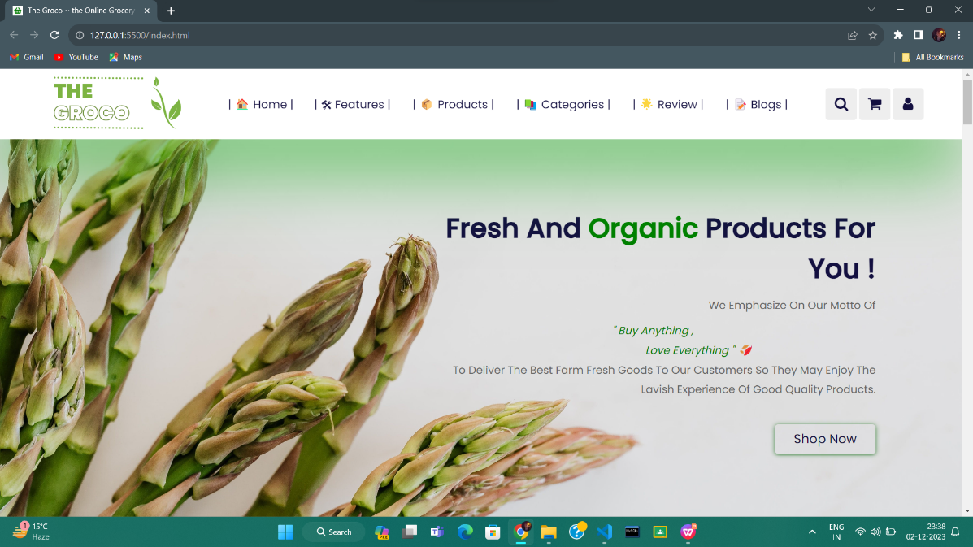

The website uses an HTML consisting of multiple meta tags, keywords, ids, alt attributes, etc. to make the site SEO friendly.As users land on 'The Groco's' front page, they're greeted with a visually appealing and intuitive interface. The design is clean, featuring strategically placed elements that cater to both user engagement and search engine visibility. The layout prioritizes quick access to key sections such as featured products, categories, features ,reviews and blogs, optimizing user navigation.

**6.1 Title**

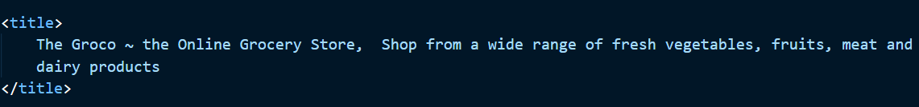



Title should consist of keywords and be descriptive.The title tag of an SEO-friendly website serves as a critical element for both search engines and users. Positioned within the HTML head section, the title tag succinctly encapsulates the content and purpose of a webpage.

In the context of 'The Groco,' our SEO-optimized grocery website, the title tags are meticulously crafted. Each title tag is unique, concise, and strategically includes relevant keywords that align with the content of the webpage. For instance, the homepage might feature a title tag that not only represents the brand ('The Groco - Online Grocery Store') but also incorporates specific keywords related to grocery shopping, such as ' home delivery' 'cash on delivery,' or 'high end products.'

These title tags are crafted with user intent in mind, aiming to attract clicks from search engine results by providing a clear indication of what the page offers. Moreover, they comply with character limits recommended by search engines to ensure complete visibility in search results, enhancing both relevance and readability.

**6.2 Meta Tags**

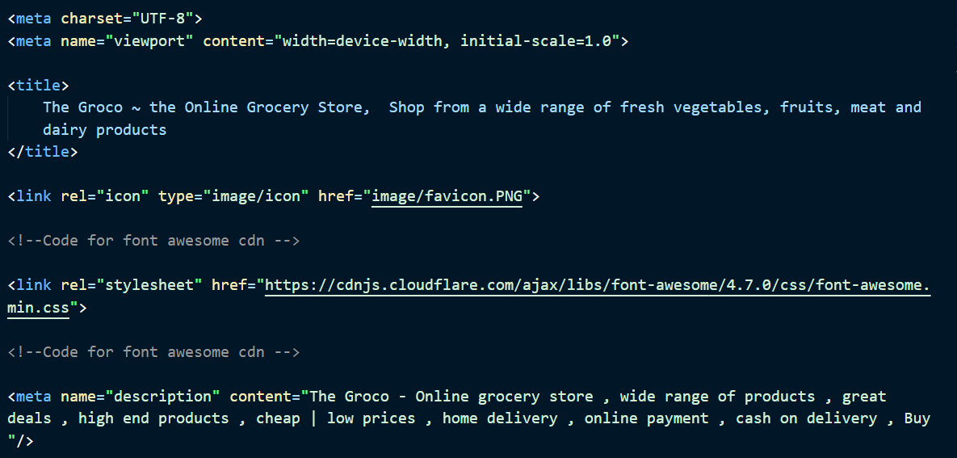

Meta tags help in SEO algorithms and also to make the site more mobile friendly. In 'The Groco,' meta tags are strategically utilized to provide concise yet informative snippets that describe the content of each webpage. The meta title tag encapsulates the page's primary focus, incorporating relevant keywords and compelling messaging within the recommended character limit. For instance, a product page might feature a meta title that includes the product name, key attributes, and a call-to-action, aimed at attracting user clicks in search results.

Additionally, meta description tags in 'The Groco' offer a brief but compelling overview of the webpage's content. Crafted with user intent in mind, these descriptions entice users to click by highlighting unique selling points, special offers, or distinctive features, while also incorporating essential keywords for relevance.

**6.3 Class, Alt and Id attributes**

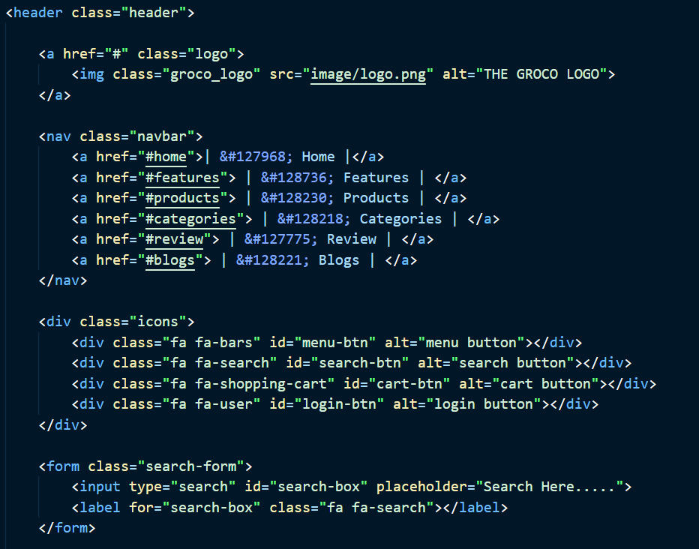

Class, Alt and Id attributes are very helpful both in making use of CSS and JavaScript, and also to make the site more user friendly and adds keywords to individual elements to increase the keyword count.

**6.4 Media Queries**

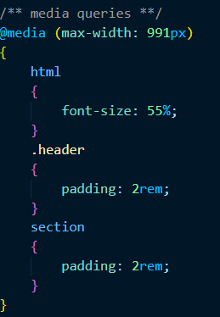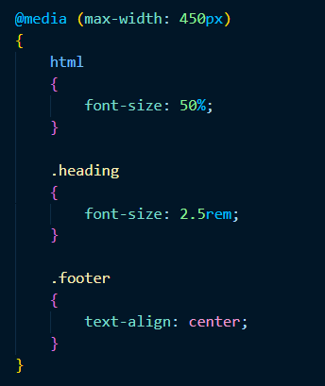

**Media queries** were used to make the website more mobile friendly and responsive. They help to make the website look good on mobile.

Media queries are pivotal tools in crafting responsive and adaptable designs for 'The Groco' website. Leveraging CSS, media queries allow 'The Groco' to dynamically adjust its layout, styles, and content presentation based on the user's device characteristics, such as screen size, resolution, or orientation.

By incorporating media queries, 'The Groco' ensures an optimal viewing experience across various devices, including desktops, tablets, and mobile phones. For instance, different style rules can be applied using media queries to resize images, adjust font sizes, or restructure page layouts to accommodate smaller screens without compromising usability or visual appeal.

**6.5 Mobile View**

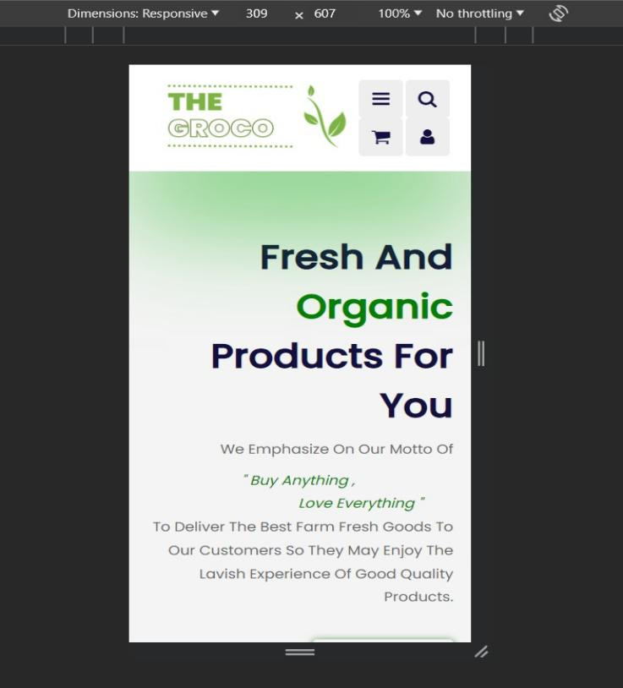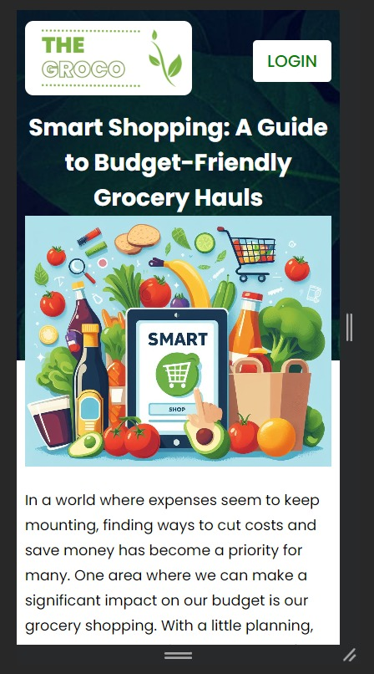

The pages have been designed to be **responsive**,

i.e, they look great on a computer

and mobile devices alike !

**6.6 Use Of Javascript**

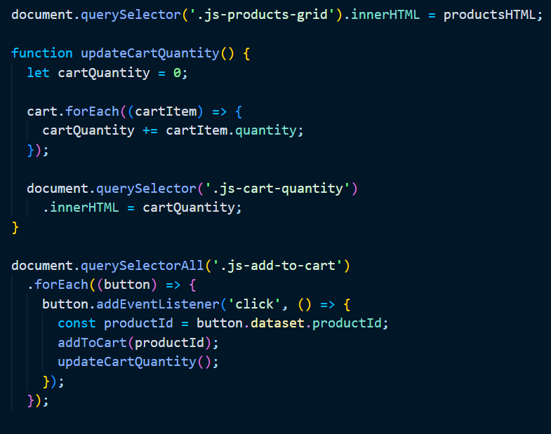

Javascript has been used to automate and enhance the working of the webpages like checkout, add to cart and sign in page.

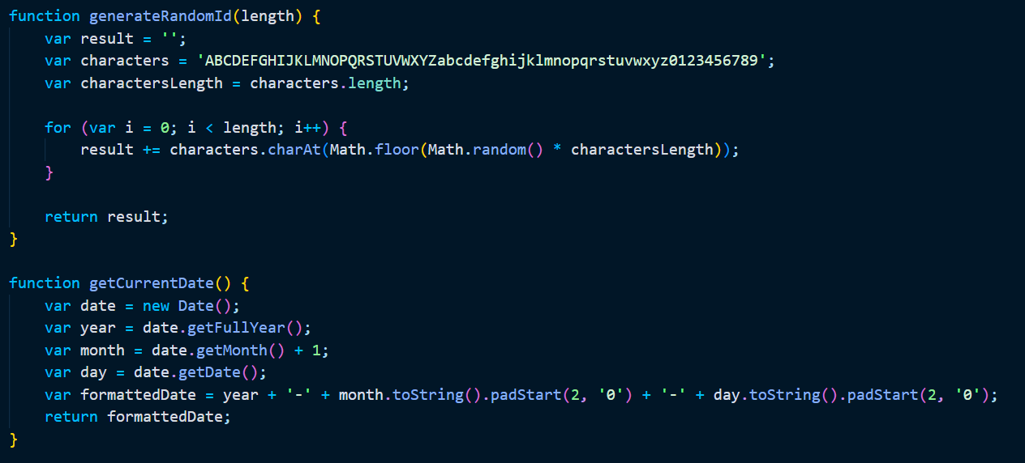

**6.7.1 GitHub**

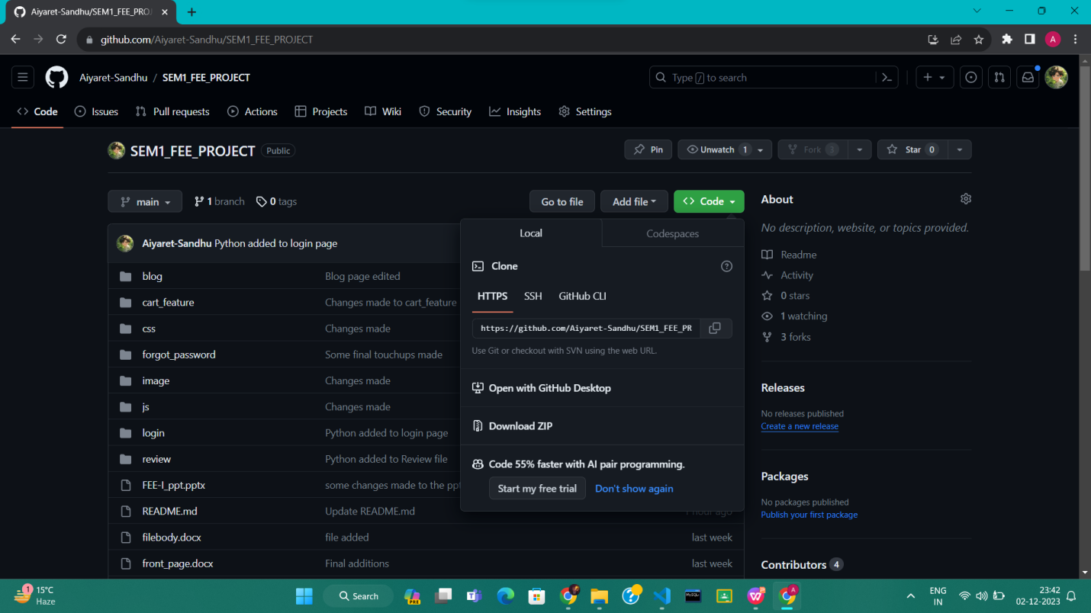

GitHub repository for the FEE Project, showing the code for the online grocery store Groco. Using GitHub as a version control system (VCS) for 'The Groco' project offers several advantages for our team of front-end engineering students. GitHub serves as a centralized platform where team members can collaborate, manage, and track changes to the project's codebase effectively.

Through GitHub's version control features, every modification made to the code is tracked, allowing for easy identification of changes, rollbacks, and the ability to work on different versions simultaneously. This ensures that the project progresses smoothly while minimizing the risk of conflicts or code discrepancies.

Link to Repository : https://github.com/Aiyaret-Sandhu/SEM1_FEE_PROJECT.git

**6.7.2 GitHub Proof**

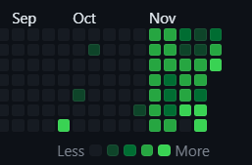

Contribution graph showing activity from August to November, with most activity occurring in October. Our README.md file contains an execution link uses the github deployment to run our project online.

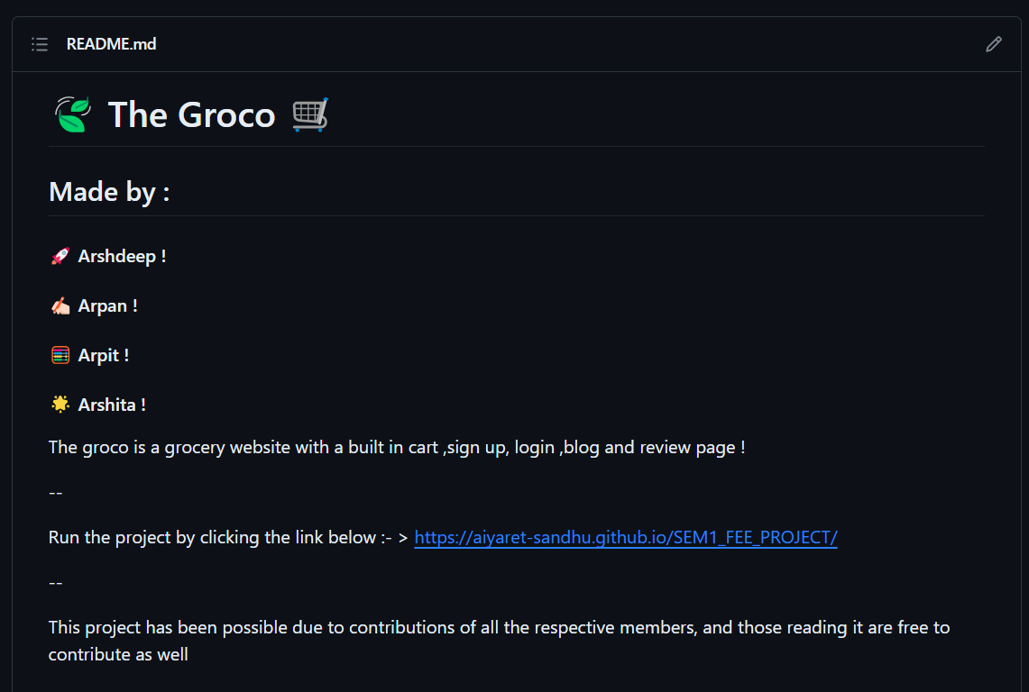

* 1. **Map of Store**

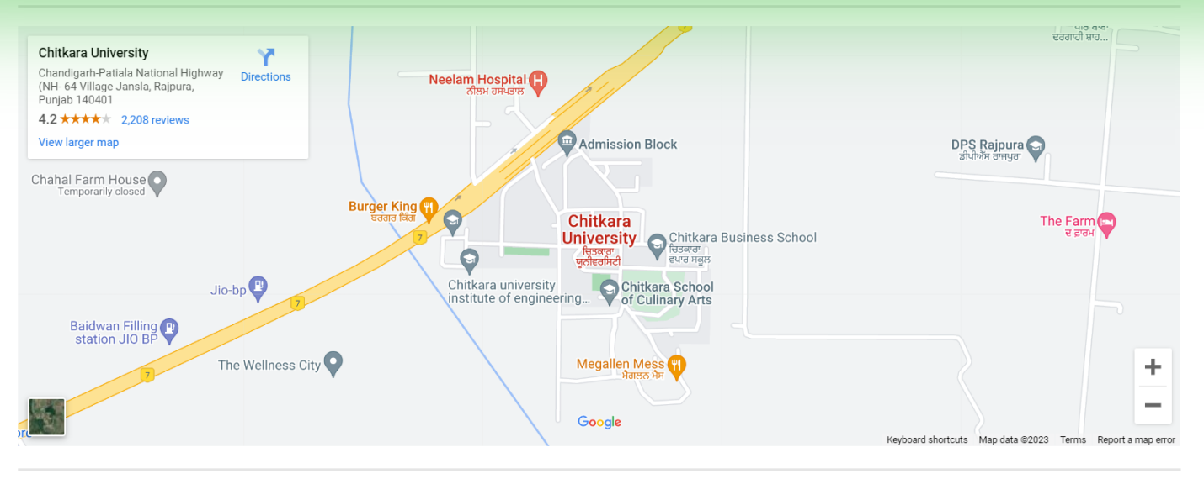

A Google Maps screenshot of the Chitkara University campus in Jansla, Punjab, India, centered on the university's Admissions Block.Integrating a map feature into 'The Groco' website offers a valuable enhancement, especially for an online grocery platform. By incorporating a map, users can benefit from visualizing store locations, delivery areas, or pickup points, enhancing their overall shopping experience.

**6.9 Login Page**

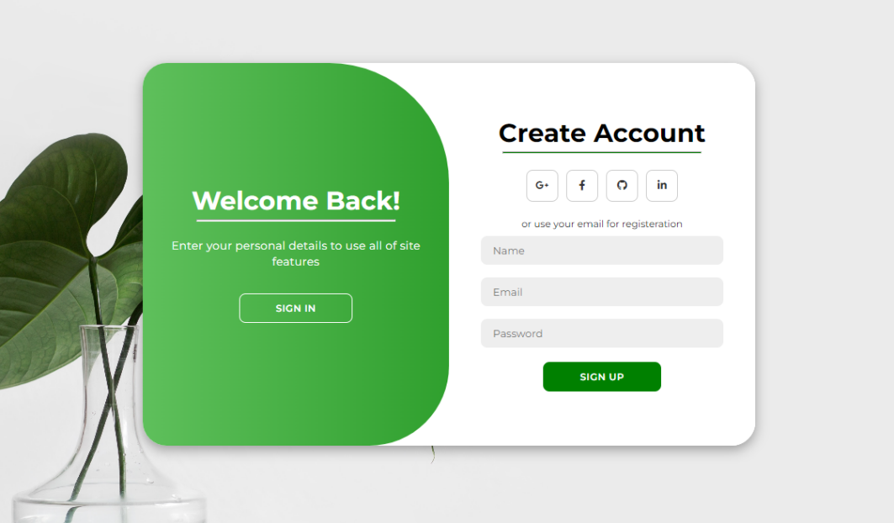

A green and white sign up form with fields for name, email, and password, and a "SIGN UP" button.

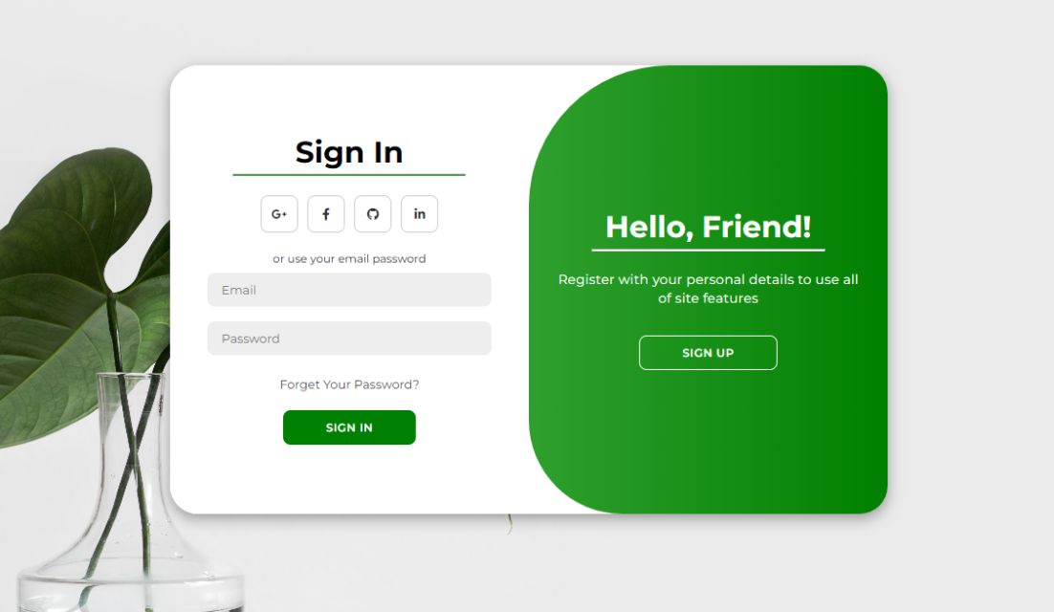

A green and white sign-in page with fields for email and password, a "SIGN IN" button, and links to register for a new account and reset a forgotten password.

**6.10.1 Buying Option**

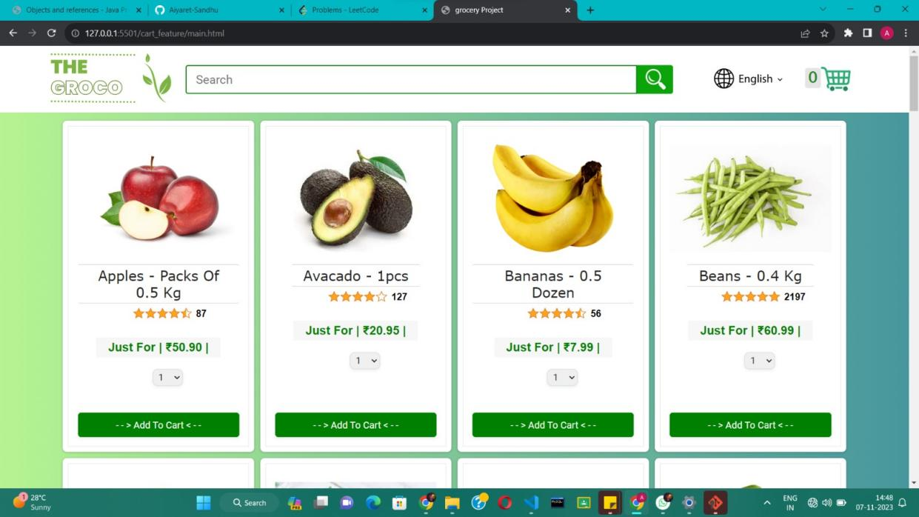

A screenshot of the GROCO website showing fresh fruits and vegetables for sale, including apples, avocados, bananas, and beans, with prices listed. Clicking on Add to Cart, automatically adds the product to the cart. Which is editable and uses Javascript to auto-correct and auto-calculate the net price.

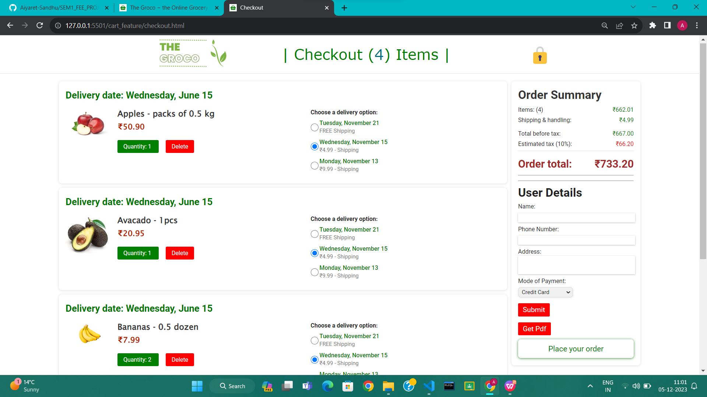

**6.11 Blog page**



The button to go on Blog page in Groco webpage.

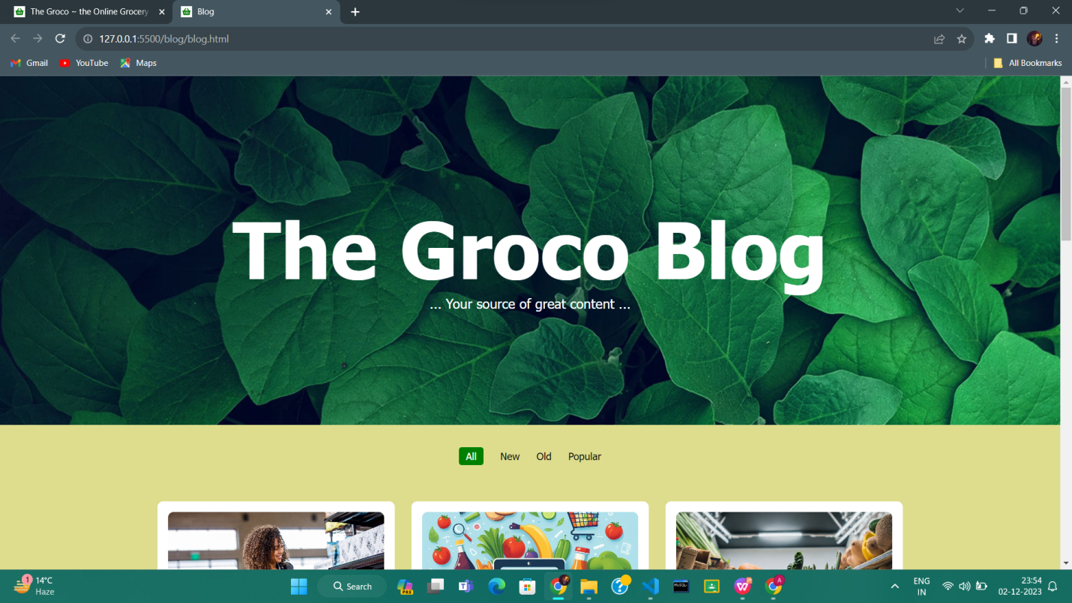

A screenshot of the Groco blog website, a source of information on grocery shopping and healthy eating.A grocery blog website serves as an invaluable resource for food enthusiasts, home cooks, and anyone passionate about culinary exploration and grocery shopping. It provides a platform to share informative, engaging, and relevant content centered around various aspects of groceries, cooking, recipes, nutrition, and lifestyle.

Such a website could feature diverse content, including cooking tips, recipe ideas using seasonal ingredients, nutritional insights, product reviews, meal planning guides, and discussions about sustainable food practices. The blog might also highlight grocery shopping hacks, budget-friendly meal ideas, or ways to minimize food waste, catering to a wide audience interested in optimizing their grocery shopping experience.

**6.11.2 Description in blogs**

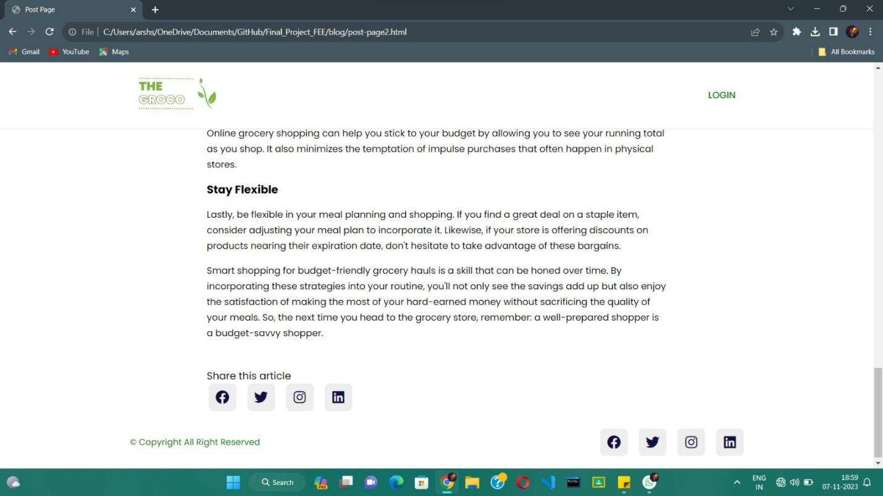

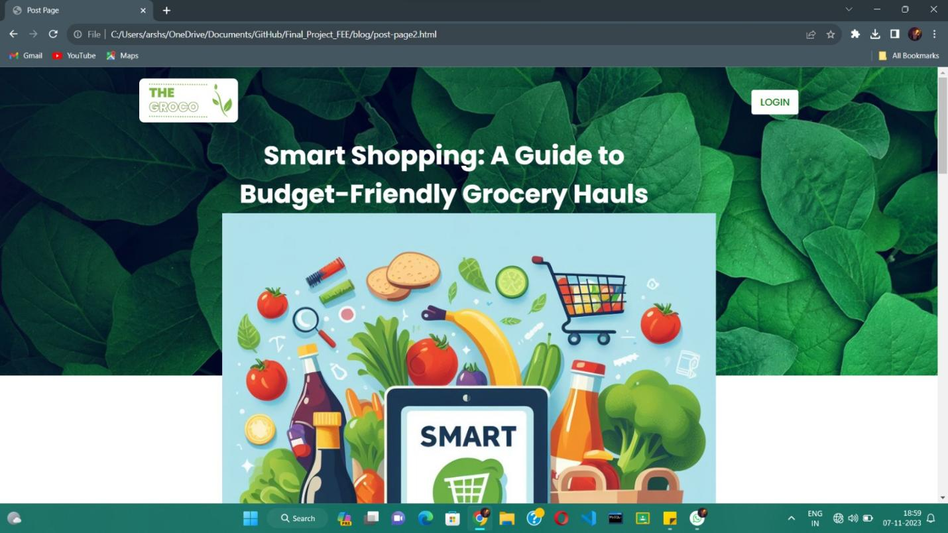

A screenshot of the Groco blog post "Smart Shopping for Budget-Friendly Grocery Hauls", with a photo of a grocery cart filled with fresh fruits and vegetables.

**6.12 Review**

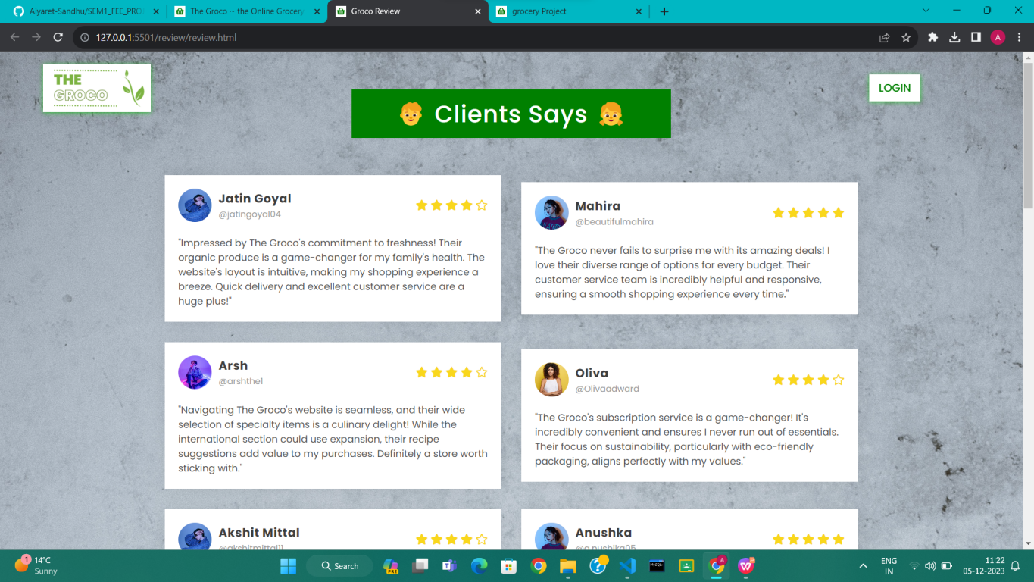

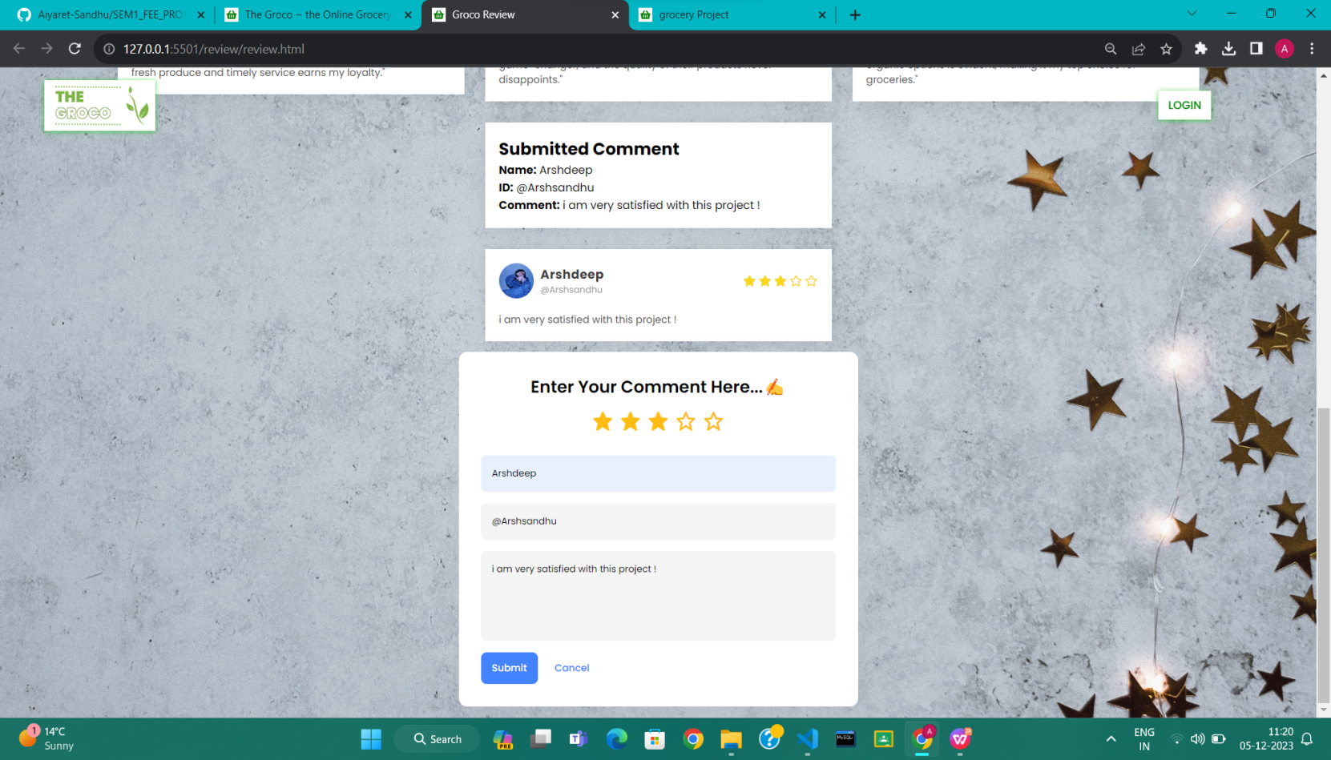

**Furthurmore,**  we have added a user review page that displays user review. where you can add your review as well !

**6.13 Invoice Download**

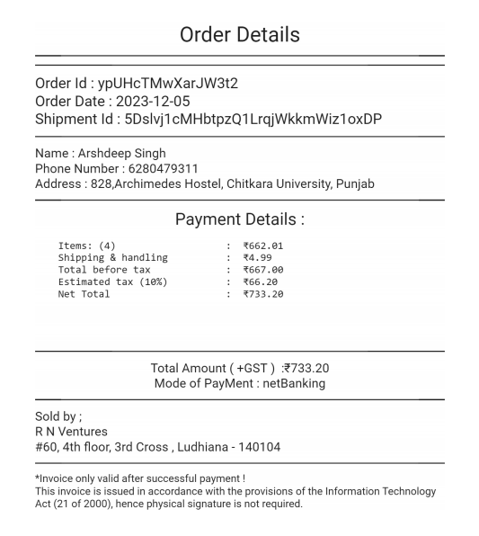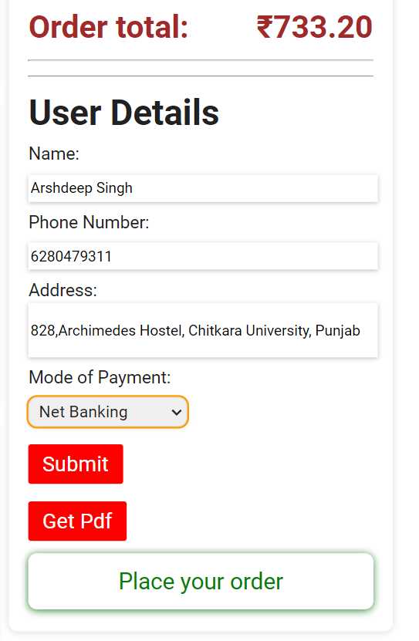

After filling the details, on clicking the **SUBMIT button -- > Get pdf Button ,** downloads the invoice ! . furthurmore on clicking place order , opens the past orders.

1. **Conclusion**

In conclusion, the development of 'The Groco' stands as a testament to our collective dedication and proficiency in front-end engineering. Our endeavor to create a user-friendly, intuitive, and SEO-optimized platform has resulted in a dynamic online grocery store poised to make a significant impact in the digital market. Through meticulous attention to SEO principles, we've ensured enhanced visibility, higher rankings, and increased organic traffic, facilitating a seamless user experience.

The amalgamation of innovative design elements, responsive frameworks, and strategic SEO implementation has empowered 'The Groco' to stand out in the competitive online retail landscape. By prioritizing user needs and leveraging the power of search engine optimization, we've established a robust foundation for continued growth and success.

This project has not only enriched our technical skills but also honed our collaborative abilities as a team. As aspiring front-end engineers, we recognize the importance of marrying technical prowess with user-centric design, and 'The Groco' embodies this philosophy.

We extend our gratitude to our mentors, peers, and the educational institution for their unwavering support throughout this enriching learning experience. 'The Groco' is not merely a culmination of our academic pursuits but a testament to our passion for crafting functional, innovative, and SEO-friendly digital solutions that resonate with users."

**LIST OF REFERENCES**

* **<https://fonts.google.com/>**
* **<https://supersimple.dev/>**
* **<https://swiperjs.com/>**
* **<https://www.canva.com/create/logos/>**
* **<https://www.fontawesome.com/>**